Body Condition Scoring Horses: Step-by-Step

As we understand more about the impact that obesity and emaciation have on equine health, it is imperative that we strive to keep our horses at an optimum body condition.

By Fernanda Camargo, DVM, PhD; Laurie Lawrence, PhD; and Bob Coleman, MS, PhD, PAS, of the University of Kentucky Department of Animal and Food Sciences
As we understand more about the impact that obesity and emaciation have on animal health, it is imperative that we strive to keep our horses at an optimum body condition. Since 1983, a procedure developed by Don Henneke, PhD, has served to provide a standard body condition scoring system that can be used across breeds and by all horse people. The system assigns a numerical score—1 through 9—based on the amount of fat that has accumulated in the important areas used to assess horses’ body condition.

The Body Condition Scoring System
The Henneke system assesses accumulated fat both visually and by palpation in each of six areas: ribs, behind the shoulder, withers, loin, tailhead, and neck. A numerical value is assigned based on the fat accumulated in all six areas (Table 1).
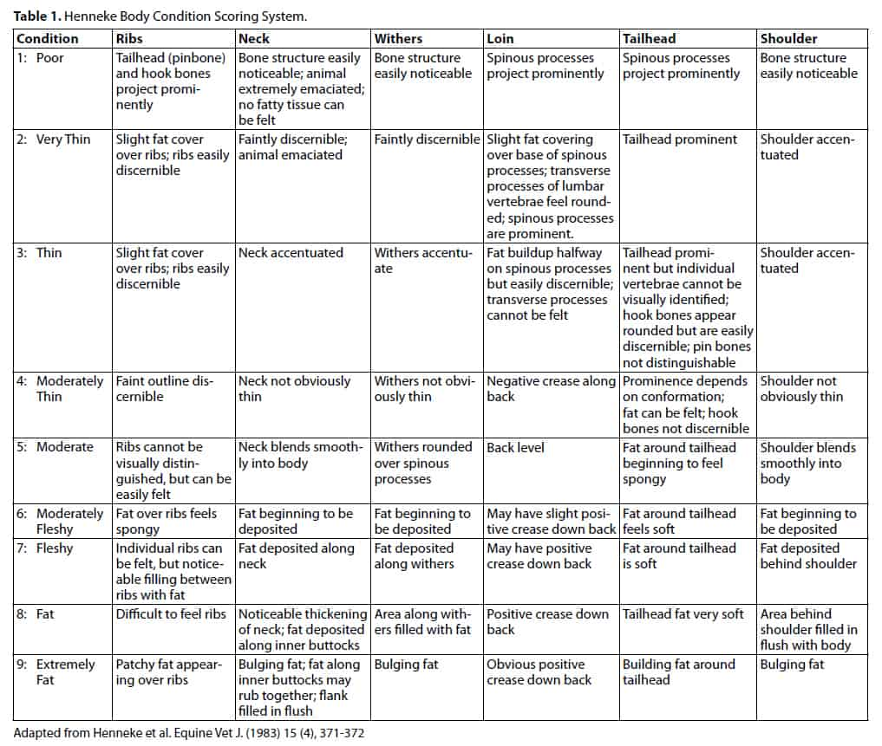

Ribs
The first place to look when assessing a horse’s body condition score (BCS) is the ribcage. If ribs are easily seen, the horse will have a score over the ribcage below a 5. If you cannot see the ribs, then the score should be a 5 or above. During winter and spring it might be difficult to see ribs because of the horse’s coat, so it is always important to run your fingers across the ribcage to assign the correct score.
A very thin horse will have prominent ribs—easily seen and felt—with no fat padding. As the horse gains weight and body condition, a little padding can be felt around the ribs. By score 5, the ribs will no longer be visible, but can be easily felt. Once the body condition score is above 7, the ribs become more difficult to feel.
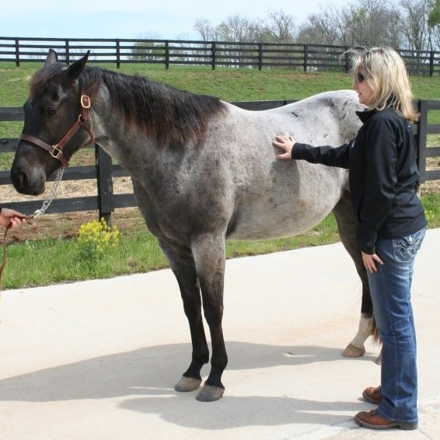

Shoulder
A BCS of 5 means the shoulder blends smoothly with the body. At increasing condition scores, fat is deposited behind the shoulder and becomes bulging. This observation is especially true in the region behind the elbow. The shoulder’s bony structures will become more visible as the scores drop below 5.


Withers
If a horse is very thin, no fat will be deposited between the top of the shoulder blade and the spinal vertebrae, making the two structures easily discernible. As the horse’s condition score increases, fat fills in between the top of the shoulder blade and spinal vertebrae; so, at a condition score of 5, the withers will appear rounded. As horses approach the high end of the condition scoring scale, the withers will be bulging with fat.
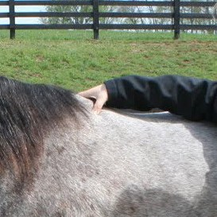

Loin
The loin is the area of the back just behind where the saddle sits. At a condition score of 5, the loin area will be relatively level—the spine is not sticking up, nor is there a dent or crease along the spine. At condition scores below 5, the spine starts to become prominent; this is sometimes called a “negative crease.” A very thin horse will have an obvious ridge down the back where the vertebrae of the spine become obvious. As the condition score increases above a 5, fat begins to build up on either side of the spine and a visible crease starts to appear.

Tailhead
In a very thin horse, the tailhead is prominent and easily discernible. Once the horse starts gaining weight, fat fills in around the tailhead. As the condition score exceeds 7, the fat will feel soft and begin to bulge.

Neck
In a very thin horse, you might be able to see the neck’s bony structures. As the horse gains condition, fat will be deposited on the top of the neck. At a condition score of 5, the neck blends smoothly into the body. Body condition scores of 8 and 9 are characterized by a neck that is thick all around with fat evident at the crest.

Overall Score
After each area is assessed and assigned a score (not all horses will get the same score at each location) you can average all the scores to get to a final overall score. For example, a horse might score 6 on some areas and 7 on others. For research purposes, the overall score can have decimal numbers, but for practical purposes, most people would record a value of 6+ or 7-.

Putting the System to Work
Horses can perform almost every activity at a BCS of 5. Many athletic horses are kept at a BCS of 5, sometimes 6, depending on their discipline. Some equine athletes, such as endurance horses, will have condition scores between 4 and 5.
However, keeping broodmares at condition scores below 5 could reduce their reproductive efficiency. In addition, horses with condition scores below 5 could lack the fat stores necessary to withstand a cold winter or other stressful situation.
On the other hand, horses that have condition scores above 6 could be less exercise tolerant than their trimmer counterparts, and very fat horses could put extra stress on bones, joints and hooves.
Horse owners should regularly condition score their horses to determine whether a change in body condition would be desirable.

Bottom of Form

